**Requirement: Adherence to standards, best practices, and/or principles (https://digitalprinciples.org/principles/):**

[Projects must demonstrate adherence to standards, best practices, and/or principles. For example, the Principles for Digital Development.](https://eur03.safelinks.protection.outlook.com/?url=https%3A%2F%2Fdigitalprinciples.org%2Fprinciples%2F&data=04%7C01%7Csrilekha.chakrabarty%40undp.org%7Cb3fff5b524c2471ae87208d9ba01b474%7Cb3e5db5e2944483799f57488ace54319%7C0%7C0%7C637745338778706494%7CUnknown%7CTWFpbGZsb3d8eyJWIjoiMC4wLjAwMDAiLCJQIjoiV2luMzIiLCJBTiI6Ik1haWwiLCJXVCI6Mn0%3D%7C3000&sdata=LJcboKyF11lwbO1AC2jk%2FNfXx3ZFoaRVygwT77wQhJQ%3D&reserved=0)

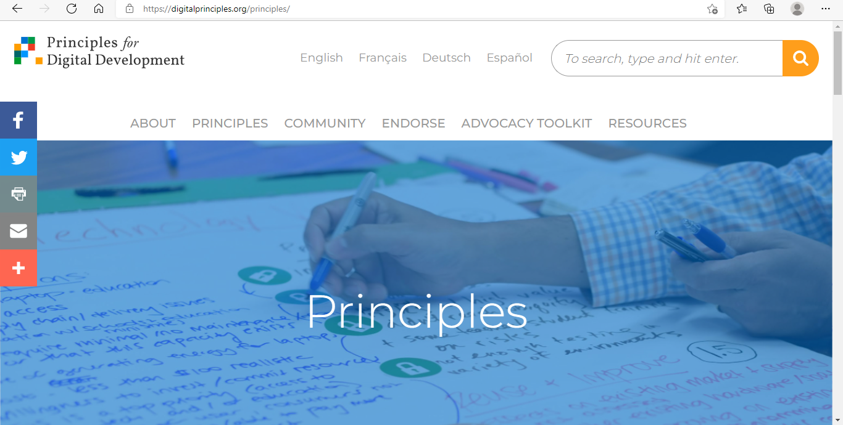

**Approach taken for development of Aajeevika:**

|  |  |
| --- | --- |
| **Standards** | **Remarks/Associated documentation** |
| Design With the User | User survey for the buyers as well as the sellers was done using google form and the responses were analysed to design UI/UX of the application. Survey questionnaire is put on Github (https://github.com/UNDPIndia/Aajeevika) |
| Understand the Existing Ecosystem | Similar applications were analysed and based on the limitations of existing applications and needs of the end users, Aajeevika application was designed. Inputs were also taken from the Digital X (international experts in UNDP) |
| Design for Scale | The database architecture is designed in such a way to accommodate scale.(more regions/states/countries, sectors, products, diverse users etc). The application is built to scale. |
| Build for Sustainability | The application is built through a long term partnership between UNDP and govt. of Uttarakhand. Under this partnership UNDP is committed to provide technical support in terms of advisory support, monitoring support , operations, maintenance etc. Government is ready to provide funding for further scale up of the application. |
| Be Data Driven | Through this application the buyers could connect with SHG women/Cluster Level Federation (sellers) to make real time purchases. Further the application provides data insights on trend based on the feedback provided on the app for both buyers and sellers. Such analysis will be used to figure out the demand supply gaps and take necessary actions to optimize them in future. Field visits were done by UNDP team. |
| Use Open Standards, Open Data, Open Source, and Open Innovation | Open APIs- The application is designed to provide an open API to extract the data that can be used by any external application/users.  Open Data- The application is designed to support open data architecture enabling sharing data amongst a large collection of systems and query engines. The govt of Uttarakhand may or may not be ready to share complete data set though. As of now, some part of data (govt schemes etc.) are open whereas as transaction on marketing platform is login based).  Open Source -Open source softwares is being used. Kotlin is used for android mobile app development. Php laravel is used for web version ( front end ) and MySQL for backend.  The PHP license is a BSD-style license and OSI approved. Kotlin comes under Apache license, which is an OSI approved license.  URL: <https://opensource.org/licenses/Apache-2.0>  We have put the source code and associated documentation is available on public repository -Github (https://github.com/UNDPIndia/Aajeevika) and is open for the feedback/suggestions from the community. |
| Reuse and Improve | The source code is uploaded on Git Hub, for anyone to reuse and enhance the features in the application. Similarly the designer of the application ( including UNDP team) is continuously scanning for reusable components on github and other open source platforms. |
| Address Privacy & Security | In India, we have only a draft Privacy bill that was issued in 2018, however, it is yet to be implemented. It is related to security of PII data in India. So we are using the UN privacy policy. |
| Be Collaborative | The details of the project are put on UNDP website for wider visibility and open collaboration. This link is also mapped as subdomain of UNDP website (aajeevika.undp.org.in). We are continuous taking feedback from Uttarakhand govt. and users from rural community) and enhancing the application. |